INDEX

Post Man Basics:
# First create an account in post man. Then go to workspaces and create a workspace choose any template api development or api testing.
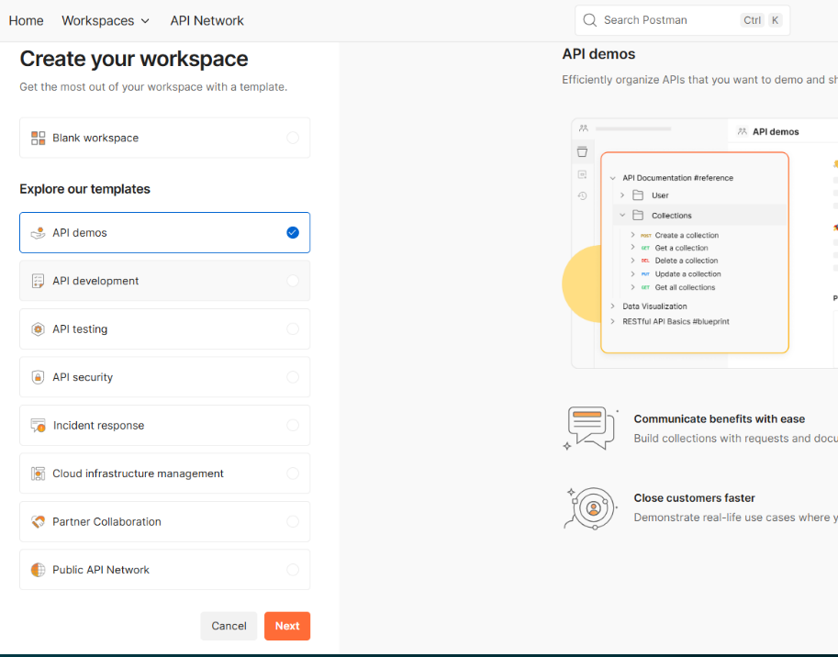

# Then create a blank collection or any preferable template and rename for eg. Postman learning

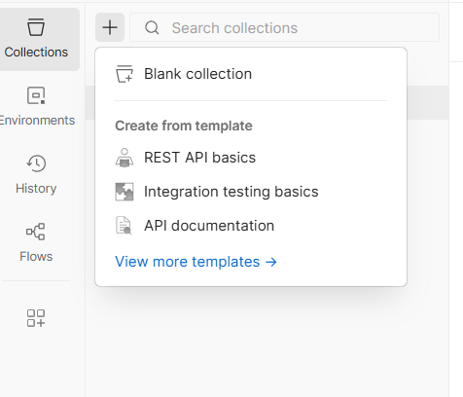

# Then add a request by clicking on the three dots of the collection and rename it.
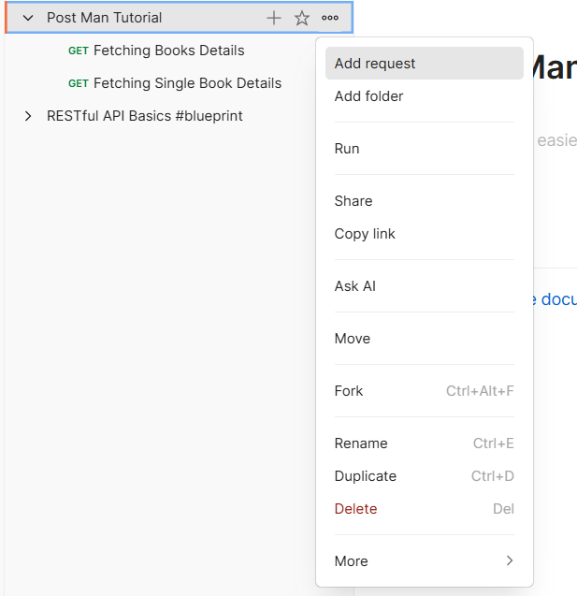

# Now we can just paste the api link and see the response in json or preview.
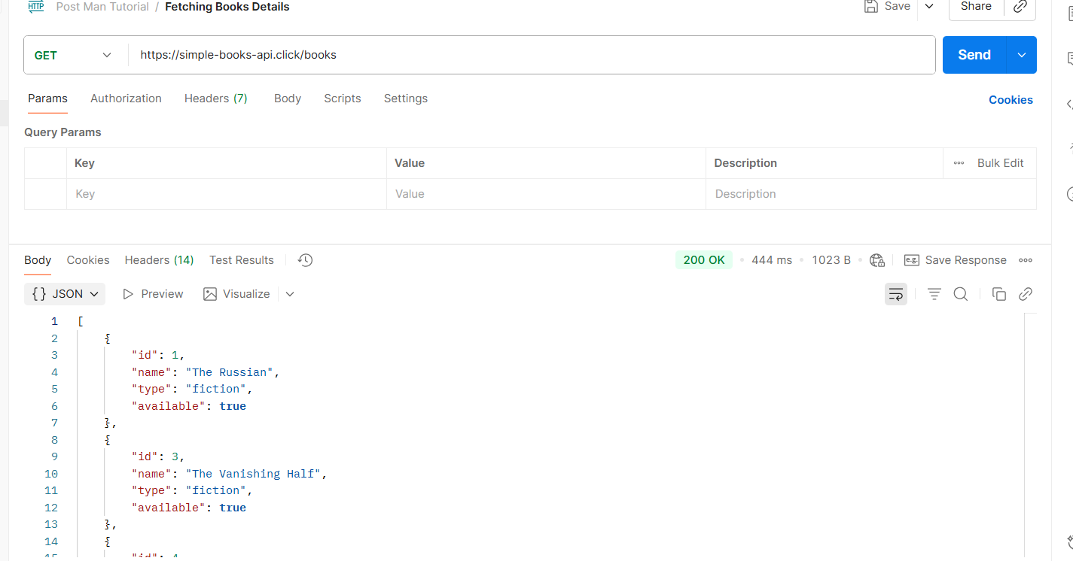

# Now we can also pass queries without writing them in the link or using params. Instead, we can use the postman’s params. We can just edit the key and value and get our query response. Like we set the key to type and value to fiction so that we can get only fiction books. But we must read the documentation to know if our params key is valid or not.
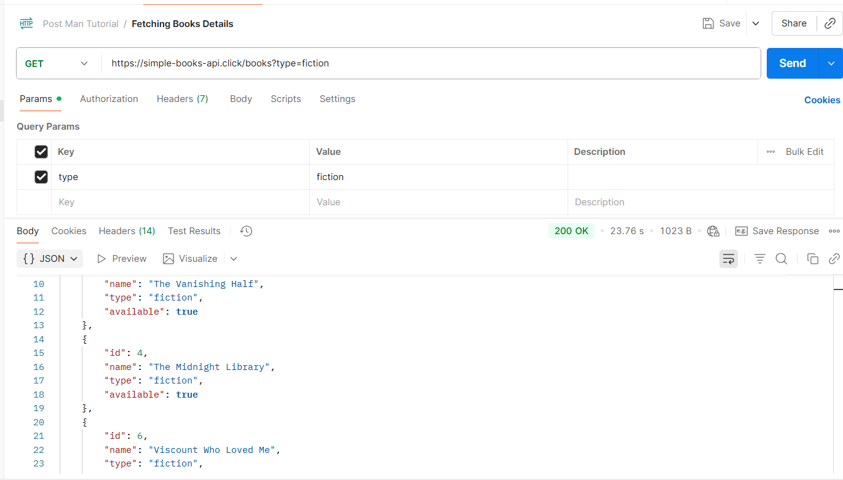

# We can also save our response as by clicking on save responses and also export our collection by clicking on three dots then click on more and export.

# Then we can also add path parameters just typing :bookid after the books/ . Then in the params section we will automatically get our path variables as key-value. We can set the key to bookid and value to 2. To get the book with bookId as 2. We can also directly access the data by directly writing 2 in link like this books/2
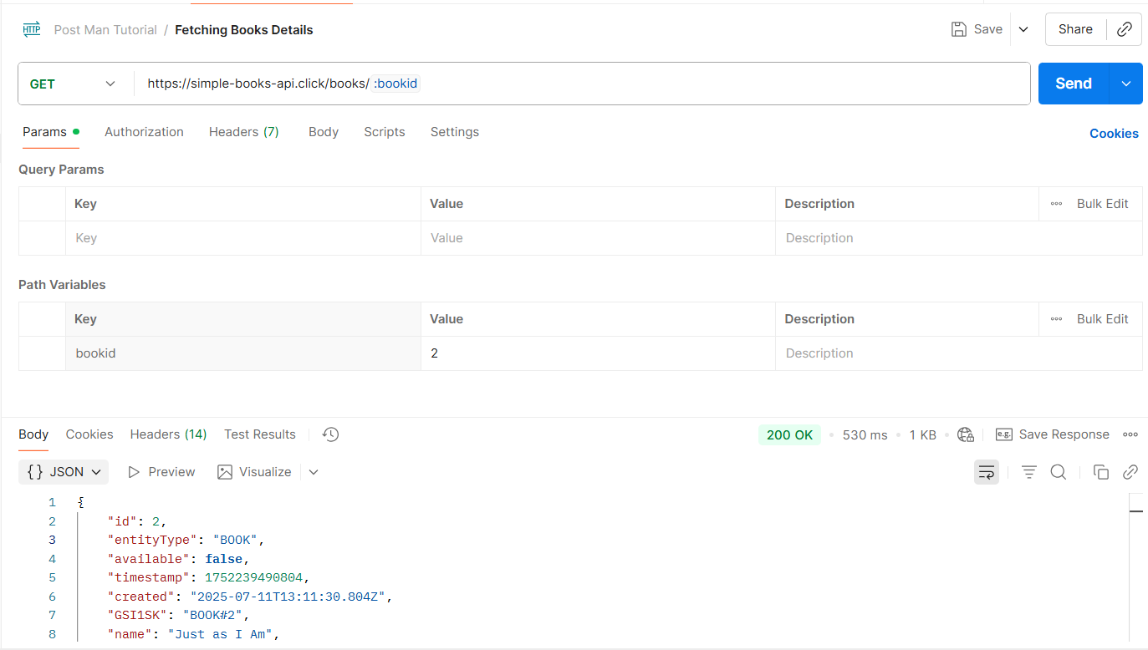

Post Method:
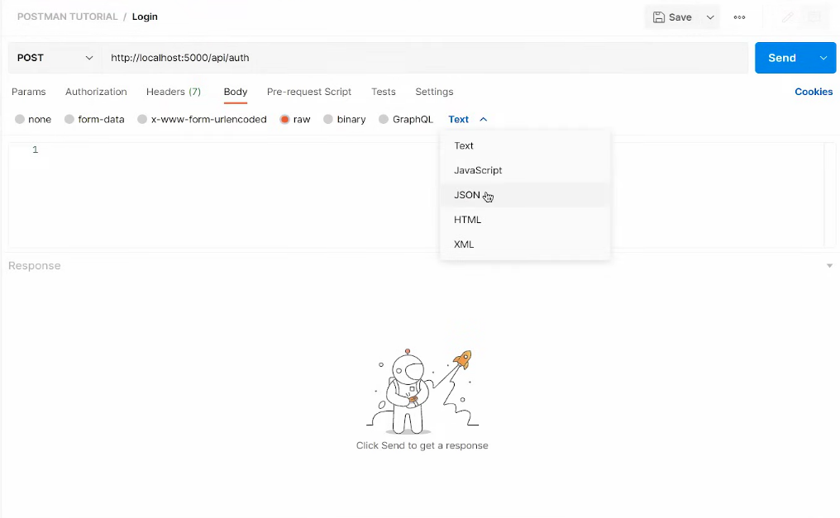
# Add a new request and rename it. Select Post method then in the body section select raw then set Text to json and write the data we want to post as json format.

# But make sure the server accepts json format. Then we can also send data in headers. Just go to the Headers section and edit the key-value just like params.
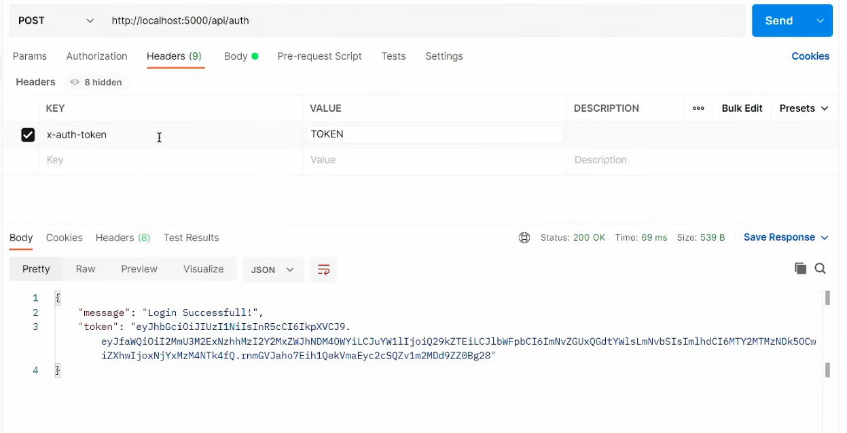

# We can also send images, videos or files in Post method. Just go the body section then select form-data then we edit the key to set our variables name like video. After that in the right side we have a drop-down option to set text to files then in the values click on select files and upload the file.
